

**<<CHATTER>>**

**Software Design Document**

– Hanoi, May 11 –

**Table of Contents**

I. Overview 3

1. Code Packages 3

2. Database Schema

3. Package Diagram 5

II. Code Designs 5

1. Account Management Feature 5

a. Class Diagram 5

b. Class Specifications 6

c. Sequence Diagram(s) 6

d. Database queries 6

2. Customer Feature 7

a. Class Diagram 7

b. Class Specifications 8

c. Sequence Diagram(s) 9

d. Database queries 9

3. Message Management Feature 9

a. Class Diagram 9

b. Class Specifications 10

c. Sequence Diagram(s) 10

d. Database queries 11

4. General Feature 11

a. Class Diagram 11

b. Class Specifications 11

c. Sequence Diagram(s) 13

d. Database queries 13

5. Marketing Feature 14

a. Class Diagram 14

b. Class Specifications 14

c. Sequence Diagram(s) 15

d. Database queries 15

6. Restaurant Management Feature 17

a. Class Diagram 17

b. Class Specifications 17

c. Sequence Diagram(s) 18

d. Database queries 18

7. Admin Feature 18

a. Class Diagram 18

b. Class Specifications 19

c. Sequence Diagram(s) 19

d. Database queries 19

III. Database Design 20

1. Database Schema 20

2. Sql queries 21

# I. Overview

## 1. Code Packages/Namespaces

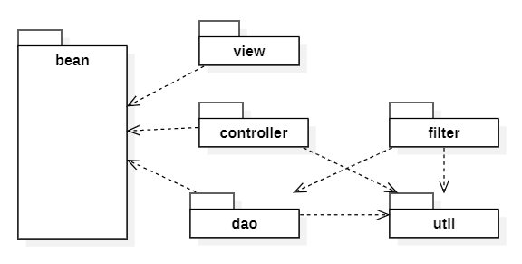

***Package descriptions & package class naming conventions***

| **No** | **Package** | **Description** |
| --- | --- | --- |
| *01* | *controller* | *Control flow into model and update view*  *Package name: Controller* |
| *02* | *model* | *A database, file, or a simple object*  *Package name: Model* |
| *03* | *view* | *Display data to screen* |

## 2. Coding Conventions : standard coding conventions

## 

## 3.Package diagram :

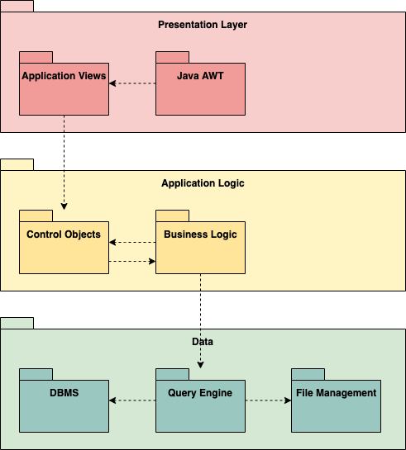

# II. Code Designs

## 1. Account Management Feature

### a. Class Diagram

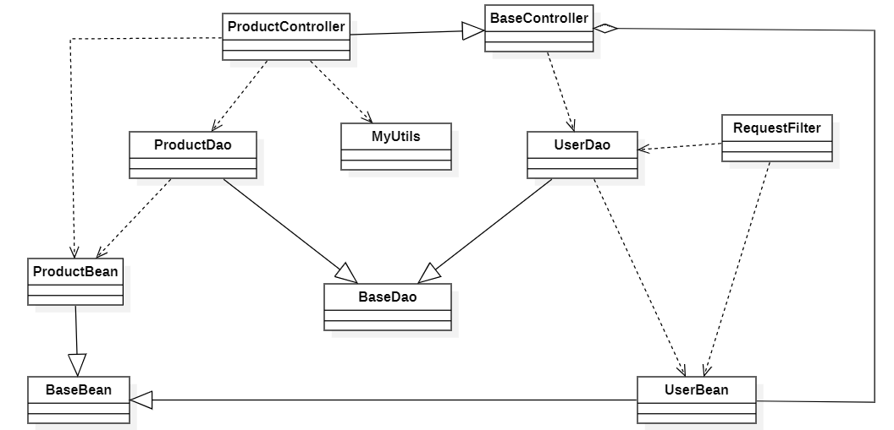

### b. Class Specifications

#### LoginController Class

***Class Methods***

| **No** | **Method** | **Description** |
| --- | --- | --- |
| *01* | *doGet* | *redirect to login page* |
| *02* | *doPost* | *search the database for username and password and return true if found* |

#### LogoutController Class

***Class Methods***

| **No** | **Method** | **Description** |
| --- | --- | --- |
| *01* | *processRequest* | *end session* |

#### 

#### RegisterController Class

***Class Methods***

| **No** | **Method** | **Description** |
| --- | --- | --- |
| *01* | *doGet* | *redirect to register page* |
| *02* | *doPost* | *create new account and insert into database* |

#### ResetPassword Class

***Class Methods***

| **No** | **Method** | **Description** |
| --- | --- | --- |
| *01* | *doGet* | *redirect to reset password page* |
| *02* | *doPost* | *take action type to choose a method to execute* |
| *03* | *sendAGPassword* | *send an auto-generate password to user’s email, redirect to the confirm page.* |
| *04* | *confirmAGPassword* | *If user input correct password, send redirect to the update password page.* |
| *05* | *updatePassword* | *update user’s input password into database* |

#### ChangePassword Class

***Class Methods***

| **No** | **Method** | **Description** |
| --- | --- | --- |
| *01* | *processGet* | *redirect to change password page* |
| *02* | *processPost* | *if user input correct old password, update new password* |

#### EditUserProfile Class

***Class Methods***

| **No** | **Method** | **Description** |
| --- | --- | --- |
| *01* | *processGet* | *redirect to profile page* |
| *02* | *processPost* | *update user profile to the database* |

### c. Sequence Diagram(s)

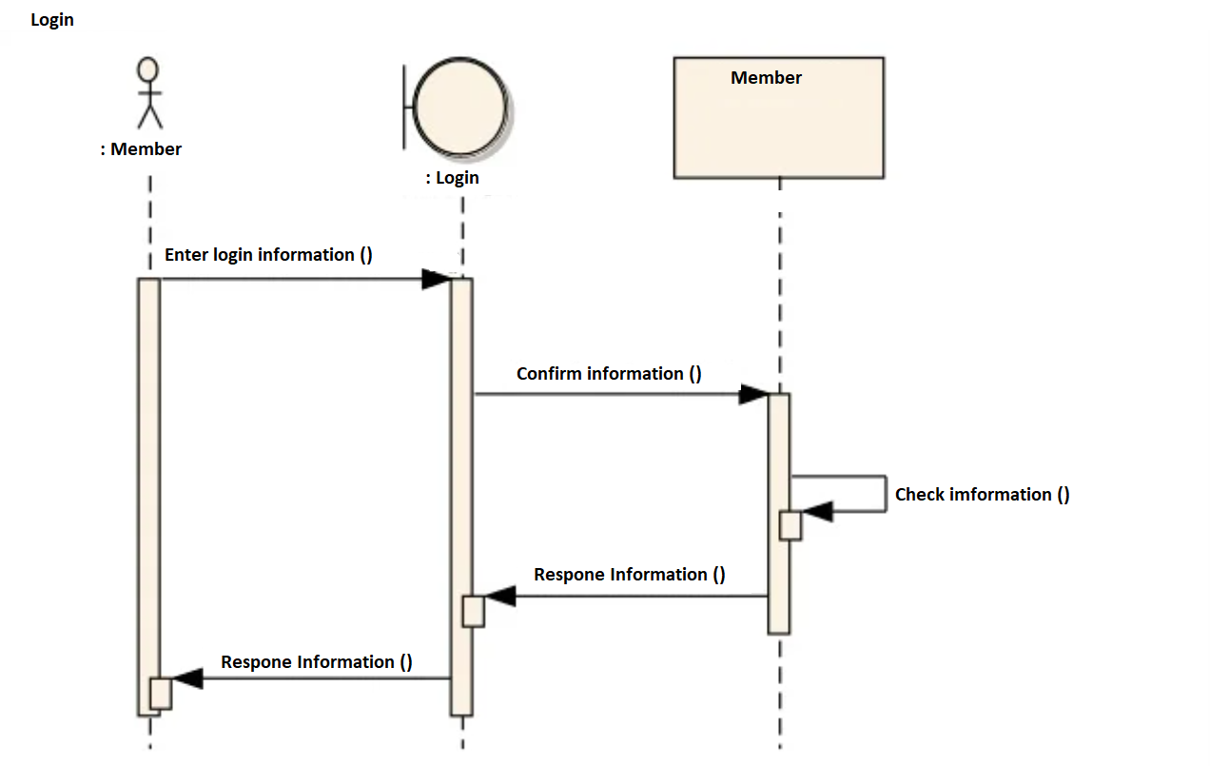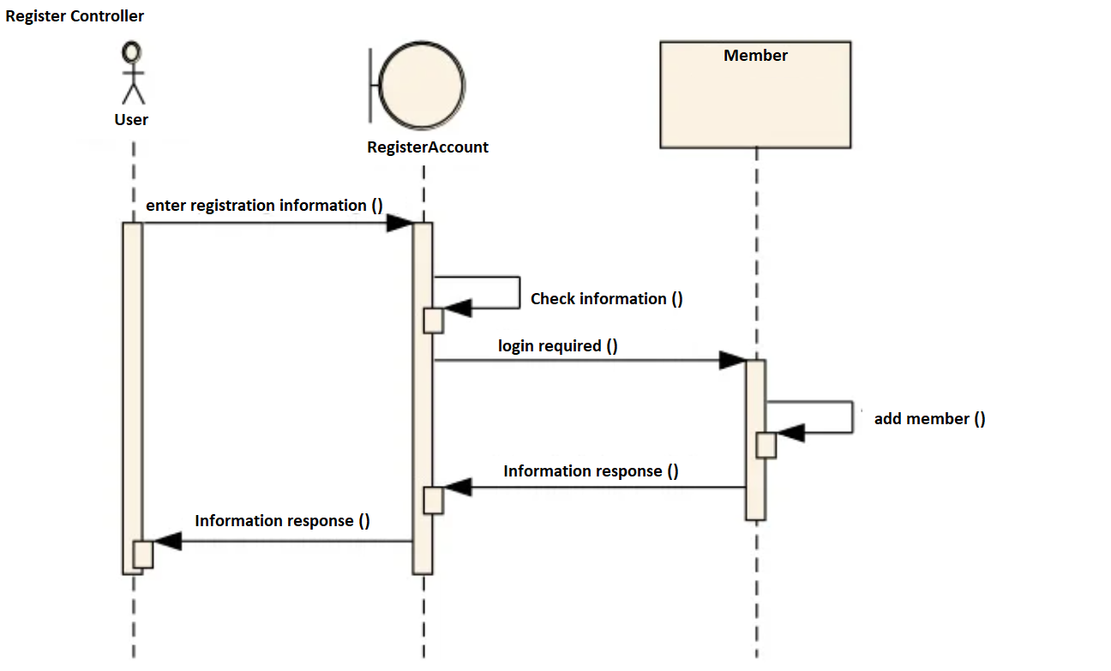

### d. Database queries

*SELECT [username]*

*,[password]*

*,[displayname]*

*FROM [users]*

*WHERE [username] = ? AND [password] = ?*

*INSERT INTO [users]*

*([username]*

*,[password]*

*,[displayname])*

*VALUES*

*(?*

*,?*

*,?)*

*UPDATE [users]*

*SET [password] = ?*

*WHERE [username] = ?*

## 2. Customer Feature

### a. Class Diagram



### b. Class Specifications

#### MyOrders Class

Class Methods

| **No** | **Method** | **Description** |
| --- | --- | --- |
| *01* | *processGet* | *load orders list from database and redirect to the order page* |
| *02* | *processPost* | *edit orders still in summited form* |

#### BuyController Class

Class Methods

| **No** | **Method** | **Description** |
| --- | --- | --- |
| *01* | *processPost* | *add customer select foods to customer’s cart in database* |

#### MyCart Class

Class Methods

| **No** | **Method** | **Description** |
| --- | --- | --- |
| *01* | *processGet* | *load cart and redirect to cart page* |
| *02* | *processPost* | *update cart is edited by customer to the database* |

#### CommentController Class

Class Methods

| **No** | **Method** | **Description** |
| --- | --- | --- |
| *01* | *processGet* | *Customers can see a comment area at the end of food detail page or restaurant detail page* |
| *02* | *processPost* | *Add comment with vote to the database (if customer vote many times, only the last vote will count)1* |

### c. Sequence Diagram(s)

[Provide the sequence diagram(s) for the feature, see the sample below]

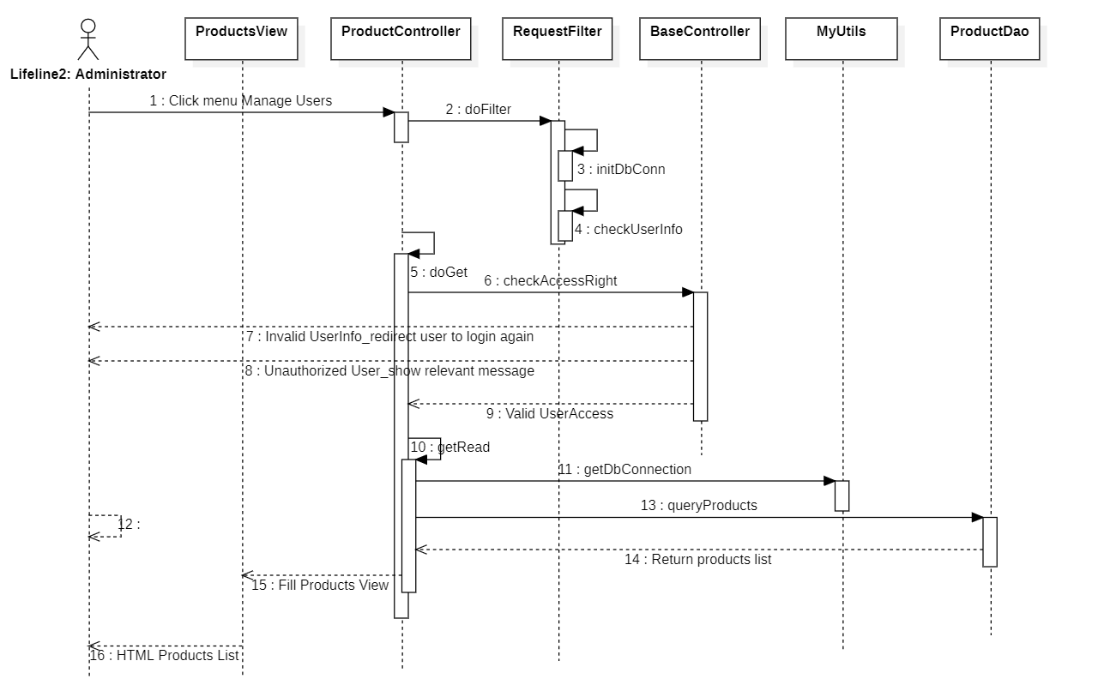

### d. Database queries

## 3. Message Management Feature

### a. Class Diagram



### b. Class Specifications

#### MesssageController Class

#### Class Methods

| **No** | **Method** | **Description** |
| --- | --- | --- |
| *01* | *processGet* | *load customer messages list from database* |
| *02* | *processPost* | *insert customer messages into database* |

### 

#### RestaurantMesssageController Class

#### Class Methods

| **No** | **Method** | **Description** |
| --- | --- | --- |
| *01* | *processGet* | load restaurant messages list from database |
| *02* | *processPost* | *insert restaurant messages into database* |

#### AdminMessageController Class

#### Class Methods

| **No** | **Method** | **Description** |
| --- | --- | --- |
| *01* | *processGet* | *load customer list with message from database and redirect to message page* |
| *02* | *processPost* | *insert customer messages into database* |

### c. Sequence Diagram(s)

[Provide the sequence diagram(s) for the feature, see the sample below]



### d. Database queries

[Provide the detailed SQL (select, insert, update...) which are used in implementing the function/screen]

## 

## 4. General Feature

Features for guest who are not login.

### a. Class Diagram



### b. Class Specifications

#### FoodController Class

Class Methods

| **No** | **Method** | **Description** |
| --- | --- | --- |
| *01* | *doGet* | *load food list from database, send food list and redirect to the home page* |
| *02* | *doPost* | *when customer click on food image, redirect to the food’s detail page* |

#### FoodDetailController Class

Class Methods

| **No** | **Method** | **Description** |
| --- | --- | --- |
| *01* | *doGet* | *redirect to a chosen food detail page* |
| *02* | *doPost* | *add numbers of order food to the cart* |

#### CategoryController Class

Class Methods

| **No** | **Method** | **Description** |
| --- | --- | --- |
| *01* | *doGet* | *load category list from database, send category list and redirect to the home page* |
| *02* | *doPost* | *when customer click on category image, view foods from that category* |

#### RestaurantController Class

Class Methods

| **No** | **Method** | **Description** |
| --- | --- | --- |
| *01* | *doGet* | *load Restaurants list from database, send Restaurant list and redirect to the home page* |
| *02* | *doPost* | *when customer click on Restaurants image, redirect to the restaurant detail page* |

#### RestaurantDetailController Class

Class Methods

| **No** | **Method** | **Description** |
| --- | --- | --- |
| *01* | *processRequest* | *redirect to a chosen restaurant detail page with foods from the restaurant* |

#### FeedbackController Class

Class Methods

| **No** | **Method** | **Description** |
| --- | --- | --- |
| *01* | *processRequest* | *redirect to the feedback page and insert feedback to the database* |

### c. Sequence Diagram(s)

[Provide the sequence diagram(s) for the feature, see the sample below]



### d. Database queries

select * from Product

select *

from Product

where Product_ID = ?

select *

from Category

SELECT *

FROM Feedback

## 

## 5. Marketing Feature

### a. Class Diagram



### b. Class Specifications

#### ListOrdersController Class

Class Methods

| **No** | **Method** | **Description** |
| --- | --- | --- |
| *01* | *doGet* | *load orderlist from database, send food list and redirect to the home page* |
| *02* | *doPost* | *update edited order into database* |

#### ListCategoryController Class

Class Methods

| **No** | **Method** | **Description** |
| --- | --- | --- |
| *01* | *doGet* | *load category list from database, send category list and redirect to the home page* |
| *02* | *doPost* | *update edited categoryinto database* |

#### ListCustomerController Class

Class Methods

| **No** | **Method** | **Description** |
| --- | --- | --- |
| *01* | *doGet* | *load customer list from database, send customer list and redirect to the home page* |
| *02* | *doPost* | *update edited customer into database* |

#### ListFeedbackController Class

Class Methods

| **No** | **Method** | **Description** |
| --- | --- | --- |
| *01* | *doGet* | *load feedback list from database, send feedback list and redirect to the home page* |
| *02* | *doPost* | *update edited feedback into database* |

### c. Sequence Diagram(s)

[Provide the sequence diagram(s) for the feature, see the sample below]



### d. Database queries

*select * from Product*

*UPDATE [Product]  
 SET [Product_Name] = ?  
 SET [Product_Price] = ?  
 SET [Product_image] = ?  
 WHERE [Product_ID] = ?*

*select \**

*from Product*

*where Product_ID = ?*

*SELECT [username]*

*,[password]*

*,[displayname]*

*FROM [users]*

*WHERE [role] = ‘Customer’*

*UPDATE [User]  
 SET [displayname] = ?  
 SET [email] = ?  
 SET [firstname] = ?  
 WHERE [username] = ?*

*select \**

*from Category*

*UPDATE [Category]  
 SET [Category_Name] = ?  
 WHERE [Category_ID] = ?*

*SELECT \**

*FROM Feedback*

## 6. Restaurant Management Feature

### a. Class Diagram



### b. Class Specifications

#### RestaurantStatsController Class

Class Methods

| **No** | **Method** | **Description** |
| --- | --- | --- |
| *01* | *processGet* | *view orders number, turnover, top customers,..* |

#### ListFoodController Class

Class Methods

| **No** | **Method** | **Description** |
| --- | --- | --- |
| *01* | *processGet* | *load restaurant’s foods list from database* |
| *02* | *processPost* | *updating edited foods into database* |

#### EditRestaurantDetailController Class

Class Methods

| **No** | **Method** | **Description** |
| --- | --- | --- |
| *01* | *processGet* | *redirect to the restaurant edit detail page* |
| *02* | *processPost* | *update restaurant information into database* |

### c. Sequence Diagram(s)



### d. Database queries

## 7. Admin Feature

### a. Class Diagram



### b. Class Specifications

#### ListUserController Class

Class Methods

| **No** | **Method** | **Description** |
| --- | --- | --- |
| *01* | *processGet* | *load users list from database, send users list and redirect to the admin home page* |
| *02* | *processPost* | *update edited users into database* |

#### UserController Class

Class Methods

| **No** | **Method** | **Description** |
| --- | --- | --- |
| *01* | *processGet* | *load chosen user from database, send and redirect to the edit page* |
| *02* | *processPost* | *update user information into database* |

### c. Sequence Diagram(s)



### d. Database queries

*SELECT \**

*FROM [users]*

*INSERT INTO [users]*

*([username]*

*,[password]*

*,[displayname])*

*VALUES*

*(?*

*,?*

*,?)*

*UPDATE [users]*

*SET [role] = ?*

*SET [displayname] = ?*

*SET [email] = ?*

*SET [role] = ?*

*WHERE [username] = ?*

## 

# III. Database Design

## 1. Database Schema

*[Provide the tables relationship like example below – following MySQL database naming convention]*

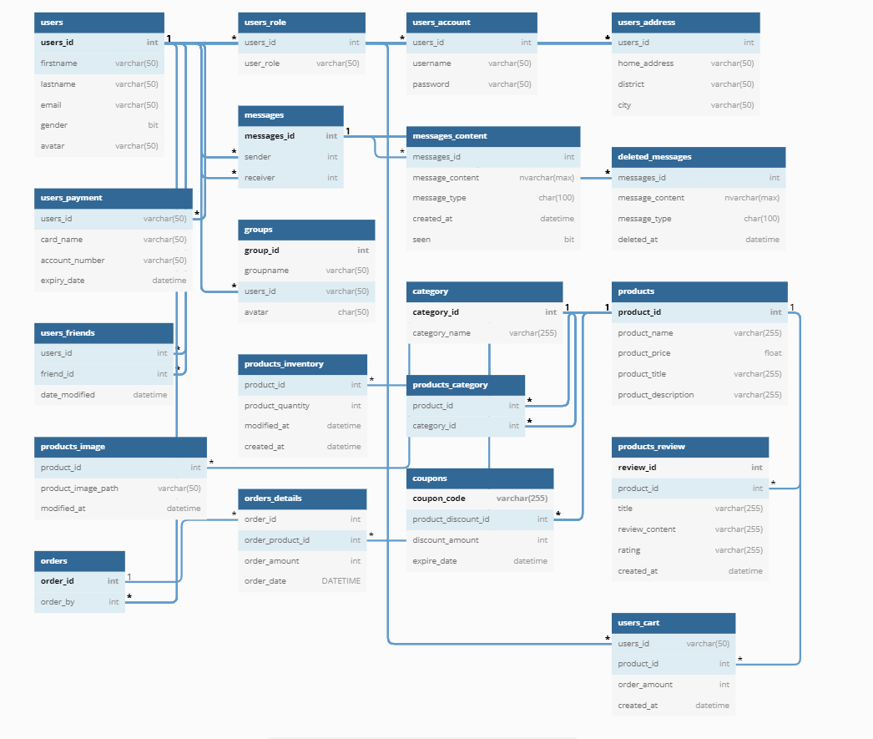

## 2. Table Description

| **No** | **Table** | **Description** |
| --- | --- | --- |
| *01* | *users* | *<Description of the table>*  *- The users table shows the user's information including username, password, last name, first name, email, gender, role*  *- Primary keys: users_id*  *- Foreign keys: <<list of foreign key fields>>* |
| *02* | *messages* | - message between customer and seller  - Primary keys: id  - Foreign key: username |
| *03* | *users_friends* | - a table to save friends via messages with the date and time of the message  - Primary keys: user_id, friend_id |
| *04* | *group* | - group includes friends list  - Primary keys: id |
| *05* | *coupon* | - coupon, including discount code and expiration date  - Primary keys: CouponCode |
| *06* | *orders* | - table containing detailed orders for each order including order number, date, and amount  - Primary keys: order_id |
| *07* | *products* | - The table contains detailed product information including name, photo, price, title, product type, product type code,  - Primary keys: Product_ID |
| *08* | *category* | - The table contains the list of products  - Primary keys: Category_ID |
| *09* | *users_role* | -List of users and their respective roles  -FK: users_id |
| *10* | *users_account* | -List of users and their login account  -FK: users_id |
| *11* | *users_address* | -List of users address  -FK: users_id |
| *12* | *users_payment* | -List of users card info:card name, account number, expiry date  -FK: users_id |
| *13* | *deleted_messages* | -all deleted messages  -FK: users_id |
| *14* | *products_inventtory* | -show all detailed information of products including quantity  -FK: product-id |
| *15* | *products_category* | -list of all product’s category  -FK: product-id |
| *16* | *products_review* | -list of all product’s review  -FK: product-id |
| *17* | *users_cart* | -list of all item in user’s cart  -FK: users_id |
| *18* | *orders_details* | - The table contains detailed order information including id, amount  - FK: order-id |
| *19* | *messages_details* | - show all detailed info of messages  -FK: messages_id |
| *20* | *message_content* | - show all Message Contents to your friends  - FK: message_id |

CREATE TABLE users(

users_id int identity(1,1) primary key,

firstname varchar(50) NOT NULL,

lastname varchar(50) NOT NULL,

email varchar(50) NOT NULL,

gender bit NOT NULL,

avatar varchar(50)

);

create table users_role(

users_id int references users(users_id) NOT NULL,

user_role varchar(50) NOT NULL

);

create table users_account(

users_id int references users(users_id) NOT NULL,

username varchar(50) NOT NULL,

password varchar(50) NOT NULL

);

Create TABLE users_address(

users_id int references users(users_id),

home_address varchar(50) NOT NULL,

district varchar(50) NOT NULL,

city varchar(50) NOT NULL

);

create table users_payment(

users_id int references users(users_id) NOT NULL,

card_name varchar(50) NOT NULL,

account_number varchar(50) NOT NULL,

expiry_date datetime

);

CREATE TABLE messages (

messages_id int identity(1,1) primary key,

sender int references users(users_id) NOT NULL,

receiver int references users(users_id) NOT NULL

);

CREATE TABLE messages_content(

messages_id int references messages(messages_id) NOT NULL,

message_content nvarchar(max) NOT NULL,

message_type char(100) NOT NULL,

created_at datetime default current_timestamp,

seen bit NOT NULL

);

CREATE TABLE deleted_messages(

messages_id int references messages(messages_id) NOT NULL,

message_content nvarchar(max) NOT NULL,

message_type char(100) NOT NULL,

deleted_at datetime default current_timestamp

);

CREATE TABLE users_friends (

users_id int references users(users_id),

friend_id int references users(users_id),

date_modified datetime default current_timestamp

) ;

create table groups(

group_id int identity(1,1) primary key,

groupname varchar(50) NOT NULL,

users_id int references users(users_id) NOT NULL,

avatar char(50)

);

create table category(

category_id int PRIMARY KEY IDENTITY(1,1),

category_name varchar(255) NOT NULL

);

create table products(

product_id int NOT NULL PRIMARY KEY IDENTITY(1,1),

product_name varchar(255) NOT NULL,

product_price float NOT NULL,

product_title varchar(255) NOT NULL,

product_description varchar(255) NOT NULL

);

create table products_image(

product_id int references products(product_id),

product_image_path varchar(50) NOT NULL,

modified_at datetime default current_timestamp

);

create table products_inventory(

product_id int references products(product_id),

product_quantity int NOT NULL,

modified_at datetime,

created_at datetime default current_timestamp

);

create table products_category(

product_id int NOT NULL references products(product_id),

category_id int references category(category_id)

);

create table products_review (

review_id int NOT NULL PRIMARY KEY IDENTITY(1,1),

product_id int NOT NULL references products(product_id),

title varchar(255) NOT NULL,

review_content varchar(255) NOT NULL,

rating varchar(255) NOT NULL,

created_at datetime default current_timestamp

);

Create table orders(

order_id int PRIMARY KEY IDENTITY(1,1),

order_by int REFERENCES users(users_id)

);

Create table orders_details(

order_id int references orders(order_id),

order_product_id int REFERENCES products(product_id),

order_amount int NOT NULL,

order_date DATETIME NOT NULL DEFAULT CURRENT_TIMESTAMP

);

Create table coupons(

coupon_code varchar(255) NOT NULL PRIMARY KEY,

product_discount_id int REFERENCES products(product_id),

discount_amount int NOT NULL,

expire_date datetime NOT NULL

);

create table users_cart(

users_id int references users(users_id) NOT NULL,

product_id int NOT NULL references products(product_id),

order_amount int NOT NULL,

created_at datetime default current_timestamp

);